|  |  |
| --- | --- |
| Home - Modern College Warje | **Progressive Education Society's**  **Modern College of Arts, Science and Commerce, Ganeshkhind, Pune-16**  **AVISHKAR: 2022**  **Zonal level Research Project Competition** |

**Date**: 07/12/2022

**Name of the Participant:** Sanskruti Joshi

**Name of the Guides:**

*Guide 1:* Dr Mrinalini Bhadane

*Guide 2:* Mrs Pradnya Pathakji

**Academic Research Coordinator**: Dr. Ravindra Kshirsagar

**Photograph of Presentation**

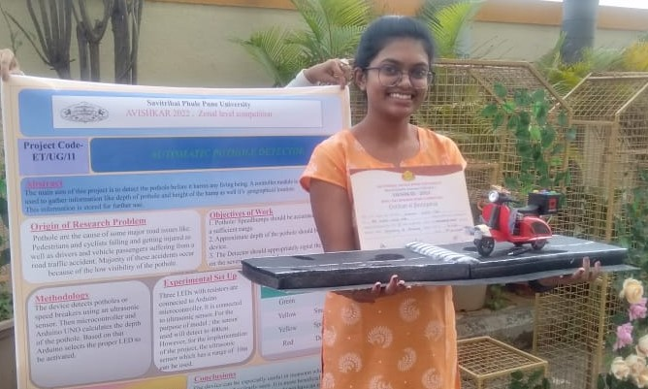

**Abstract**

 Nowadays, road accidents are a major issue in most countries. One of the reasons is due to severe irregularities in the road surface and high-speed driving. However, accidents due to road damage can be reduced by using an automatic pothole detecting device. Its general architecture is as follows; a controller module is used to gather information like depth of pothole and height of the hump as well as its geographical location. This information is stored for further use. Ultrasonic sensors are used to measure the distance between the vehicle and the damaged road. This distance is also stored and computed. If the distance between the two is within 10 meters, an LED light is activated to alert the driver. The colour of the LED indicates the depth of the pothole.

Hence, this device can be especially useful in monsoon when road damage cannot be clearly seen. It is more beneficial to two-wheeler vehicle drivers; since they do not have an inbuilt facility to provide this service.

**Key words:** Pothole Detector, Ultrasonic Sensors.